Create Development Plan with Copilot
Screenshot for writing a Plan
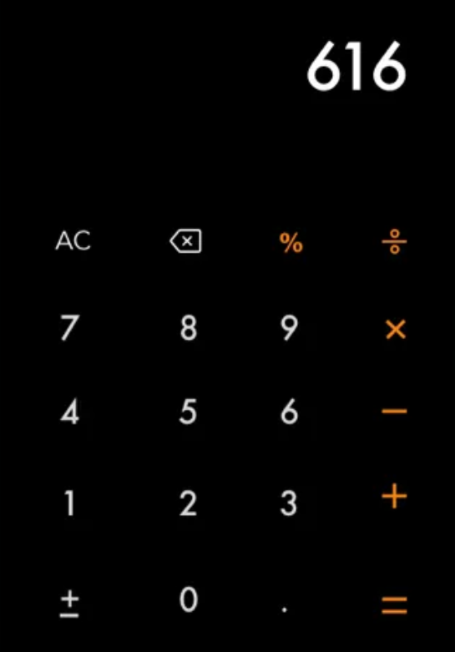
Prompt to build an with Ask mode (plan mode not yet released)
Create a structured build plan for a Calculator App based on a provided screenshot, using Vite template with React and TypeScript.
Follow clean architecture and reusable component patterns. Split logic into components and utilities where appropriate. Use clear, consistent naming and React best practices.
Requirements:
- One display at the top.
- A 4×5 button grid with these exact buttons and layout: AC, backspace, %, ÷ | 7, 8, 9, × | 4, 5, 6, − | 1, 2, 3, + | ±, 0, ., =
- Simple CSS with a centered card layout and clean minimal design.
Output format
- steps (list 5–6 short todos)
- project setup (commands to create project)
- file structure (list reusable parts and logic separation like components, utilities, ...)
- return all the plan as one code block formatted as markdown text
Prompt to build an with Plan mode
- Create a step-by-step plan to build a calculator app from the screenshot using Vite + React + TypeScript template.
- The app must have one display and a 4×5 grid with the same buttons from screenshot (AC, backspace, %, ÷; 7–9, ×; 4–6, −; 1–3, +; ±, 0, ., =) in the same positions.
- Keep simple CSS and a clean centered card layout.

Build the Calculator App from the Plan
Plan
- # Calculator App Build Plan

- ## Steps

- 1. Create new Vite project with React + TypeScript
- 2. Set up project structure and create component files
- 3. Implement calculator logic and state management
- 4. Build UI components with basic styling
- 5. Add button functionality and display logic
- 6. Polish styling and test functionality

- ## Project Setup

- ```bash
- npm create vite@latest calculator-app -- --template react-ts
- cd calculator-app
- npm install
- ```

- ## File Structure

- ```
- src/
- ├── components/
- │ ├── Calculator.tsx # Main container component
- │ ├── Display.tsx # Calculator display
- │ ├── ButtonGrid.tsx # Grid layout for buttons
- │ ├── Button.tsx # Reusable button component
- │ └── styles/
- │ └── Calculator.css # Styles for components
- ├── utils/
- │ ├── types.ts # TypeScript interfaces/types
- │ ├── calculatorLogic.ts # Core calculation functions
- │ └── constants.ts # Button configs and constants
- ├── hooks/
- │ └── useCalculator.ts # Custom hook for calc logic
- ├── App.tsx
- └── main.tsx
- ```

- ## Component Breakdown

- ### Key Components

- - `Calculator`: Main container, manages state
- - `Display`: Shows current input and results
- - `ButtonGrid`: Manages button layout
- - `Button`: Reusable button with variants

- ### Core Logic

- ```typescript
- interface CalculatorState {
- display: string;
- previousValue: number | null;
- operation: string | null;
- clearOnNext: boolean;
- }

- type ButtonType = "number" | "operator" | "function";

- interface ButtonConfig {
- label: string;
- type: ButtonType;
- value: string | number;
- }
- ```

- ### Button Layout

- ```typescript
- const BUTTON_CONFIG = [
- [
- { label: "AC", type: "function", value: "clear" },
- { label: "⌫", type: "function", value: "backspace" },
- { label: "%", type: "operator", value: "percent" },
- { label: "÷", type: "operator", value: "divide" },
- ],
- // ... remaining button rows
- ];
- ```

- ## Styling Approach

- - Use CSS Grid for button layout
- - CSS variables for consistent theming
- - Responsive design with mobile-first approach
- - Clean, minimal card design with subtle shadows

Style the Calculator for a Modern Look
Prompt to improve layout and card styling
Keep the 4×5 keypad and logic unchanged. Use a light page background and a dark calculator card. Center the calculator vertically and horizontally. Set a fixed width of 480px, add generous padding, rounded corners, and a soft shadow for a clean, modern look.
Prompt to improve button shapes and hover effects
Make all calculator buttons circular and the same size. Center the text or symbol inside each button. Arrange buttons in a 4×5 grid with equal spacing between them. Use equal padding for consistent look. Add hover effects based on type: light gray for control buttons, orange for operator buttons, and dark gray for digit buttons.

Add Input Limits and Thousands Formatting
Prompt to limit total digits
Limit input to 10 total digits (digits before + after the decimal). When the limit is reached, block extra characters but still allow backspace/editing. Show a short message with a hint below the display and auto-hide it after 3 seconds.
Prompt to format thousands
Format large numbers in the display by adding a space as a thousands separator (e.g., 12 345.67). Apply formatting dynamically as the user types or when showing the result. Ensure formatting does not affect calculations or stored numeric values. Also make font size a bit smaller.
Pompt to fix entering digits
A user is not able to enter another amount after entering the first 10-digit amount and clicking an operator button.

Replace Custom Logic with a Formatting Library
Prompt for libraries research
Search for JavaScript libraries that can format numbers with thousands separators. Compare popular options and summarize pros, cons, and a short code example for each.
Prompt to use built-in Intl.NumberFormat library
Refactor the formatNumber utility to use the built-in Intl.NumberFormat instead of custom logic. Format numbers with spaces as thousand separators (like 1 234 567). Always show dot (.) as the decimal separator. Keep code minimal and reusable.

Write and Run Unit Tests with Copilot
Prompt to write unit-tests
Write unit tests for the calculator app using Vitest. Cover all main use cases for all components, hooks, utils, and main app logic. Use .spec.ts or .spec.tsx naming for test files. Keep all tests near their corresponding files. I also want to have line coverage.

Generate Project Documentation with AI
Prompt to generate documentation
Generate developer documentation for this project and save it as DOCUMENTATION.md in the repo root. Include a short project overview and key features, technical stack, setup instructions (install, run, build, test), and usage guide with basic steps.

